**CHAPTER 1**

**INTRODUCTION**

For a large period of time the flowers were the best known for their beauty and fragrance. Flower is a very important part of a plant and is mostly used for identification of a plant. Flowers are available in a large number of colors, sizes and shapes. A flower plays a major role in producing new seeds for new growth. There are many similar looking plants which can be differentiated only on the basis of difference in the color and shape of the flower as the other vegetative parts of the plant may differ in appearance due to climatic conditions, geographical location, and various biotic and abiotic stresses(Lee and Hong 2013). Other than that a flower can also tell, if the plant is suffering from a particular diseases as flowers are the most delicate part of the plant and gets affected first.

Experienced taxonomist and botanists mostly do this identification of flower just by looking at it. Whereas naive person doesn’t have encyclopedia in hand, when facing with flowers, so he/she doesn’t know what is it. Hence, they will have to take help either from guide books or web pages. Recognition is one of the major applications in computer vision. The majority of the research effort has been on the classification between different categories, such as between cars and airplanes as posed in the pascal. Many recent approaches have been successful in this area. However, we aim to use computer vision techniques to distinguish between visually similar objects. In particular, we investigate the possibility to separate flower species from each other. Flowers from different species may look very similar both in shape or color inter-class similarity and flowers from the same species may look different intra-class dissimilarity. Together, these facts result in a very interesting and challenging computer vision problem. But besides our ambition to tackle with difficult problems, there are also application-related interests in solving it. There are several books filled with information about flowers but it becomes quite difficult for human brain to remember all those details. It is quite difficult to search for a scientific name when we don’t have any information source and all we have is flower in our hand. The searching on Internet is restricted to keywords. Therefore the Internet approach is also not practical(Guru *et al* 2010).

Great efforts have been undertaken over the last half century to build machines that can see. A great number of fundamental problems have been solved. Examples of such problems are the detection of edges in images, the computation of basic flow fields representing motion throughout a sequence of images, or the point-by-point registration of a pair of stereoscopic images. At the same time, one cannot escape the impression that the biggest problems are still far ahead of us. Central to understanding images is the problem of recognizing objects in images. Humans can recognize objects effortlessly and are rarely even aware of the changes in an object’s appearance that occur, for example, due to changes in viewing direction or a shadow being cast across the object. We also readily group instances of objects, such as cars, faces, shoes, or houses into a single object category and forget about the differences between the individual members. At the same time, we can still discriminate on a sub-categorical level. On the other hand, everyone who has ever dealt with a computer has inevitably experienced that even the smallest change in the information provided to a computer can, and often does, make all the difference in the world. Teaching a machine to recognize objects is all about teaching it which differences in the raw image information matter and which don’t.

A flower has many subparts which include petals, stamen/ pistil area and sepal. The four main parts of a flower are generally defined by their positions on the receptacle and not by their function. Many flowers lack some parts or parts may be modified into other functions and/or look like what is typically another part. Out of these only stamen/ pistil area is visible when a fully grown flower is seen vertically. Hence, mostly taxonomist identifies a flower by examining the features of these areas of flower. A state-of-art recognition system often takes the whole input image and extracts features either in a dense (using grid points) or sparse (using interest points) fashion. We note that the difficulty of our problem, the high similarity between flower species, implies a high similarity in the feature space as well, which lower the classification performance. We believe that this similarity can be reduced if we first localize the flower inside the image and only extract features from the flower and discard the background clutter. This idea is reflected as deleting background of flower by which only features of flower will be visible . Keeping the above given points in our mind, a system was proposed which identifies a flower through its digital image with white background. In this system features of petals and stamen/pistil area are compared through which a flower is recognized, hence recognizing the plant. Our system can help people interested in flora to identify the flowers in order to get further information about their species. This idea can be easily extended to a more general vision of a system which takes images and provides additional information about it, like a Wikipedia using image instead of text search. The features that the software uses for flower recognition includes shape, color along with the stamen/pistil area which gives the accurate results.

The use of foreground-background segmentation in a visual classification system is a controversial issue in modern computer vision. On the one hand, the background contains information that is irrelevant in separating one class from others. This information may be converted into noise during the feature extraction and causes problem in the end classification. Several studies have reported improved classification/detection performance once accurate segmentation masks are given.

Traditional approach for flower recognition includes that the taxonomists consider the clearly visible features of flowers along with the climatic conditions of the area where that flower is found. These features include:

* Whether the flower is symmetrical i.e. looks similar from all sides or asymmetrical like orchid.
* The number of petals/ rays a flower has.
* Whether the petals are fused together or not.
* Color of the flower petal and stamen/ pistil area.
* Whether the flower exists in a cluster or individually.
* The environment of the area where the flower is found.
* The month in which that flower blooms.

**1.1 DIGITAL IMAGE AND ITS FEATURES**

When using digital equipment to capture, store, modify and view photographic images, they must first be converted to a set of numbers in a process called digitization or scanning. Computers are very good at storing and manipulating numbers, so once your image has been digitized you can use your computer to archive, examine, alter, display, transmit, or print your photographs in an incredible variety of ways. Any image from a scanner or digital camera or stored in the computer is called digital image. A digital image is made up of many tiny dots known as pixels. Depending upon size and number of dots, the clarity of picture changes. If pixels are small the image will be clearer as the size of pixel increases image becomes more blur. The amount of details that an image can hold is controlled by the resolution of image. The word resolution describes the number of pixels that make up an image(Singh and Kaur 2013).

The data stored in an image is just a series of RGB numeric color values in rows and columns. Each pixel displays one color and has a particular RGB value. But in our software instead of using RGB color model we use HSV color model as it approximately perceives and interprets color values just the way humans do. HSV is a color model that describes [colors](http://desktoppub.about.com/od/glossary/g/Color.htm) (hue or tint) in terms of their shade (saturation or amount of gray) and their brightness ([value](http://desktoppub.about.com/od/glossary/g/Value.htm) or luminance).

The HSV color wheel may be depicted as a cone or cylinder. Instead of Value, the color model may use Brightness, making it HSB (Photoshop uses HSB).

* Hue is expressed as a number from 0 to 360 degrees representing hues of red (starts at 0), yellow (starts at 60), green (starts at 120), cyan (starts at 180), blue (starts at 240), and magenta (starts at 300).
* Saturation is the amount of gray (0% to 100%) in the color.
* Value or Brightness works in conjunction with saturation and describes the brightness or intensity of the color from 0% to 100%.

The value of H if extracted and a histogram is created from that value then by detecting the highest peak we can find out the color of maximum pixels in an image(Yetirajam and Nayak 2012).

Digital image is more powerful approach for flower recognition than traditional approach. So, in this flower identification system digital image of the flower to be recognized will be the main input which will be used by the system. A brief introduction to the technologies used to develop the proposed system is given below:-

Java technology is used to develop applications for a wide range of environments, from consumer devices to heterogeneous enterprise systems. Like any programming language, the Java language has its own structure, syntax rules, and programming paradigm. The Java language's programming paradigm is based on the concept of object-oriented programming (OOP), which the language's features support(Dash and Nayak 2012).

The Java language is a C-language derivative, so its syntax rules look much like C's: for example, code blocks are modularized into methods and delimited by braces ({ and }), and variables are declared before they are used. Structurally, the Java language starts with packages. A package is the Java language's namespace mechanism. Within packages are classes, and within classes are methods, variables, constants, and so on. You'll learn about the parts of the Java language in this tutorial.

OpenCV Libraries is another name for open source computer vision library. It is an open-source BSD-licensed library that includes several hundreds of computer vision algorithms. OpenCV has a modular structure, which means that the package includes several shared or static libraries. The following are the main modules available under this library:

* core - a compact module defining basic data structures, including the dense multi-dimensional array Mat and basic functions used by all other modules.
* imgproc - an image processing module that includes linear and non-linear image filtering, geometrical image transformations (resize, affine and perspective warping, generic table-based remapping), color space conversion, histograms, and so on.
* video - a video analysis module that includes motion estimation, background subtraction, and object tracking algorithms.
* calib3d - basic multiple-view geometry algorithms, single and stereo camera calibration, object pose estimation, stereo correspondence algorithms, and elements of 3D reconstruction.
* features2d - salient feature detectors, descriptors, and descriptor matchers.
* objdetect - detection of objects and instances of the predefined classes (for example, faces, eyes, mugs, people, cars, and so on).
* highgui - an easy-to-use interface to video capturing, image and video codecs, as well as simple UI capabilities.
* gpu - GPU-accelerated algorithms from different OpenCV modules.

MySQL is a fast, easy-to-use RDBMS being used for many small and big businesses. MySQL is developed, marketed, and supported by MySQL AB, which is a Swedish company. It is a relational database management system RDBMS that runs as a server providing multi user access to a number of databases. It is an open source database software based on SQL vocabulary which can be employed in combination with most server side languages like java. MySQL runs on all platforms such as linux , unix and windows. It provides application program interface(APIs) for many programing languages including C, C++, Java, etc.

**1.2 OBJECTIVES OF THIS STUDY**

1. To develop software for flower recognition using image processing techniques.
2. Prototype implementation and testing of proposed software.

**CHAPTER 2**

**REVIEW OF LITERATURE**

Hong *et al.* (2004) gave an approach based on region of interest. Region of interest i.e. ROI extracts the flower image from the whole image of flower including background. In addition to the approach of Das et al. color clustering method was included for segmentation. The scattering of colors of the flower region is represented by color histogram, along with which for exact comparing two shape features were included.

Zou and Nagy (2004) developed a model-based interactive flower recognition system based on the concept of Computer Assisted Visual Inter Active Recognition (CAVIAR). In the training process, each training image was interactively segmented in order to extract the flower regions. interactive process will repeat until the user accepts the recognition result. One major problem of this system is that too many user interactions have to be conducted to get high recognition accuracy.

Nilsback and Zisserman (2006) investigated to what extent ‘bag of visual words’ models can be used to distinguish categories which have significant visual similarity. They developed and optimize a nearest neighbour classifier architecture, which is evaluated on a very challenging database of flower images. The flower categories are chosen to be indistinguishable on color alone, and have considerable variation in shape, scale, and viewpoint. they demonstrated that by developing a visual vocabulary that explicitly represents the various aspects (color, shape, and texture) that distinguish one flower from another, we can overcome the ambiguities that exist between flower categories. The novelty lies in the vocabulary used for each aspect, and how these vocabularies are combined into a final classifier.

Fukuda *et al* (2008) developed a flower image retrieval system by combining multiple classifiers using fuzzy c-means clustering algorithm. In their system, flowers were classified into three categories of different structures: gamopetalous flowers, many-petaled flowers, and singlepetaled flowers. For each structure, a classifier with specific feature set was constructed. Fuzzy cmeans clustering algorithm was then used to determine the degree of membership of each image to each structure. The overall similarity is a linear combination of each individual similarity computed for each classifier with the weight being the degree of membership. Experimental results have shown that the multiple-classifier approach outperforms any single-classifier approach. However, it is too rough a classification mechanism to classify flowers into three different categories according to the number of petals.

Holmes *et al* (2009) explained that supervised learning can be used to segment/identify regions of interest in images using both color and morphological information. The algorithms are also showing promise in other domains. The success of the method depends heavily on the use of color, the relative homogeneity of object appearance and on interactivity. As is often the case in segmentation, an algorithm specially tailored to the application works better than using broader methods that work passably well on any problem. Our main innovation is the interactive feature extraction from color images.

Kim *et al*(2009) shows that conventional flower or leaf recognition studies have some restrictions and limitations. These include a sharp drop in recognition rate due to the varying positions and number of relevant objects in the original object image. Hence, this research work suggests and implements a mobile-based flower recognition system using Difference Image Entropy (DIE) and contour features of the flower from the original image with multiflower objects. In system framework includes 1) WiBro Net.- based transmission and designation module of the relevant flower object by drawing the flower region of the user's interest, 2) contour feature extraction module, and 3) DIE-based flower recognition module.

Pornpanomchai *et al.* (2011) has an objective to build software for computers that uses leaf or flower to identify a plant. This software has 4 different modules i.e. acquisition of image, preprocessing of image, recognition of image and result display. In image acquisition the flower image or leaf are captured on a background of white research work. Different processing algorithms are applied on flower or leaf in image preprocessing part. In image recognition, 8 main features are used for extraction. Finally in display result, the results best matched are displayed.

Singh and Vij (2012) proved that effective image enhancement can be done through histogram processing. Image enhancement is means to improvement of an image appearance by increasing or decreasing dominance of a feature or ambiguity between different regions of image. Four histogram techniques were tested on a low contrast image.

Vibhute *et al* (2012) conducted a survey that intended to focus on the application of image processing in agriculture field such as imaging techniques, weed detection and fruit grading. The analysis of the parameters has proved to be accurate and less time consuming as compared to traditional methods. Image processing has been proved to be effective tool for analysis in various fields and applications. Many times expert advice may not be affordable, majority times the availability of expert and their services may consume time. Image processing along with availability of communication network can change the situation of getting the expert advice well within time and at affordable cost since image processing was the effective tool for analysis of parameters. Application of image processing can improve decision making for vegetation measurement, irrigation, fruit sorting, etc.

Aleya and Samanta (2013) proposed that trading of flowers, production of seeds, nursery and potted plants and segmentation of useful oil from flowers are included in floriculture. Firstly, the image gathered from different regions for the process is viewed and enhanced. Secondly, the image disporting is done to get the targeted parts of flower. Lastly, final analysis of the detected region is done. The histogram approach is used to detect the disease taking the help of stem value. Finally the agricultural experts are looking out for consultative approach.

Apriyanti *et al*.(2013) proposed a system that uses flower images to identify different species of orchids. Different shape features are extracted using MSRM i.e. Maximal Similarity based on Region Merging. Background is segmented from the flower object with the help of MSRM. HSV color features and SVM methods are also used.

Tiay *et al*.(2014) developed image processing for flower recognition system. Classification of flower is done on the basis of color and edge characteristics. Histogram is used to derive green, hue, blue, red and saturation features. Classification is done using k-nearest neighbour algorithm. Approximately more than 80% of the result is accurate.

Note that the previous researchers extracted color or shape features from the whole image or flower region without specifically using characteristics of stamen/ pistil area. Thus software was proposed which extracts not only the shape and color feature from the whole flower region but also from stamen/ pistil area which will help us to identify flower more precisely.

**CHAPTER 3**

**MATERIALS AND METHODS**

The traditional approach for recognition of flowers is not that easy for flowers that are not part of our day to day life. To recognize a flower a person needs to have knowledge of all types of flowers including different colors, shapes and many other factors of flowers along with that he/she should also have experience in flower taxonomy. It becomes quite difficult , hectic and time consuming for a person to recognize a flower even with help from books or websites without any knowledge of keywords of flowers. People face a lot of problems in flower recognition despite of many software systems developed to help them. The search for flowers is restricted to keywords which makes it difficult for user without any knowledge in this field. Also the software systems developed are all recognizing flowers on the basis of its shape and color features but in most of the flowers the petal/ rays or stamen/pistil area acts as different entities and should be considered as such. This problem of flower detection is solved in the proposed software.

**3.1 PROPOSED SOFTWARE**

In this research work we present freeware software for recognizing flower images taken by digital cameras with white background. The proposed system takes such images as input then it extracts the H value of the flower from the HSV color model which represents the color of the input flower. Thus color feature of input flower is compared with the flowers existing in the proposed software and flowers with similar color value are extracted and saved. Once the color feature is matched color image segmentation is done to extract the shape of the flower. The largest contour is picked as shape of the flower. A contour is the connected components with same color. The shape of the flower is compared with the flowers extracted having same color as the input flower. The flowers with match factor value less than particular threshold value are extracted as they have relevant shapes to the input flower. Mostly flowers are recognized till this phase. Now input flower’s relative stamen/ pistil area is calculated. After comparison of this area the flower is mostly identified. If not an interactive interface allows user to select the flower similar to input flower hence giving us 100% accurate result. The experiment is conducted on a database consisting of 24 species that in addition to color and shape features when feature of stamen/pistil area is added result becomes more accurate.

In present study, a software developer needs to be aware of all the ways with which he/ she can fulfil the requirements of the software so that the software designed should be efficient. Also the designed software should be robust, user friendly and without errors. Hence it is necessary for a developer to follow a systematic approach while implementing various steps for the systems software development.

For the systematic development of proposed system a concept of software engineering has been used as given below:

**3.2 SOFTWARE DEVELOPMENT LIFE CYCLE (SDLC)**

SDLC is a framework that describes the activities performed at each stage of a software development project. It can also be discribed as a complete procedure of how a software is planned and developed. It is a multi-phase process in which output of each phase is used as input for next phase. All the phases of SDLC are followed by a developer during the development of every project. The various phases given below describe implementation of the proposed system:

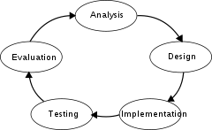

**Figure 3.1** **Stages of SDLC**

**3.2.1 SYSTEM ANALYSIS**

The goal of system analysis is to determine where the problem is in an attempt to fix the current system. Here, detailed study of operations performed by previously used system is done and data is collected on various functions of this system which answers questions like where the problem lies in the system and what changes are needed for improvement of the currently working system. In this analysis we found that in current system flowers are identified either by taking help from books or websites containg information about taxonomy of flowers. The other system is semi automatic systems where the search for flowers is restricted to keywords which makes it difficult for user without any knowledge in this field.

To solve these difficulties below given various points should be considered while planning of proposed system to solve the statement of problem:-

* This system should have a login module for user to first register himself/herself only then a use should be able to access the system to keep an acount of who used the sysem and when.
* User should have the privilege to update their information and should be allowed to delete their account after logging into the software through their unique username and encrypted passwords.
* User should have the privilege to upload an image of flower into the system to identify the flower.
* User should be able to confirm that correct image is uploaded by viewing the image and clicking on proceed button to begin processing of image.
* Along with recognition of flower user should also be given information about its scientific name.

**3.2.2 FEASIBILITY ANALYSIS**

Not everything imaginable is feasible, not even in software, it may appear to outsiders. Feasibility analysis is a process to test the proposed system in the light of its workability, fulfilment of user’s requirement, effective use of resources and their availability and its cost effectiveness. Assessing the feasibility of your proposed system is an important step before deciding to start designing your software.  A feasibility analysis helps you to assess the merit of your system idea, determine whether there is a requirement for your idea, whether the idea is financially viable, and ultimately, whether or not it is worth investing your time and money into the software system. Software feasibility has four solid dimensions:

**3.2.2.1 TECHNICAL FEASIBILITY**

Yes, this system is technically feasible, as it is within the state of art and any defects can be further reduced to a level matching the needs of application. The organization have all the resources needed to succeed as they require an expert who can operate the computer well and has knowledge of all the controls and can handles the exceptions quite efficiently. The software’s used in these projects are open source and free of cost, easily available. The technology issues that are considered for feasibility are performance, ease of learning, compatibility with other technologies the technologies used in this proposed system are java, swings, OpenCV libraries and mysql.

**3.2.2.2 SCHEDULED FEASIBILITY**

A schedule is the list of events that occur one after the other at specific interval of time. Schedule feasibility shows that weather the project will be completed on time. Here, the objective is to divide the task and time in proper way and then implement them effectively. The schedule feasibility of this project has been decided at the time of synopsis where the schedule work flow of each process along with its time is given.

**3.2.2.3 SYSTEM FEASIBILITY**

The assessment is based on an outline design of system requirements in terms of Input, Processes, Output, Fields, Programs, and Procedures. This can be quantified in terms of volumes of data, trends, frequency of updating, etc. in order to estimate whether the new project will perform adequately on a system or not. System feasibility is carried out to determine whether the company has the capability, in terms of software, hardware, personnel and expertise, to handle the completion of the project and considering this point we can say that the project is feasible because not much of extraordinary or expensive software’s are required and no extra hardware or workforce is needed. All the stuff available in the organization and some seminars which have been attended is enough to complete the project.

**3.2.2.4 ECONOMIC FEASIBILITY**

Economic analysis is the most frequently used method for evaluating the effectiveness of a new system. More commonly known as cost/benefit analysis, the procedure is to determine the benefits and savings that are expected from a candidate system and compare them with costs. If benefits outweigh costs, then the decision is made to design and implement the system. It is important to identify cost and benefit factors, which can be categorized as follows:

* Development costs.
* Operating costs.

This is an analysis of the costs to be incurred in the system and the benefits derivable out of the system. Considering this factor also we can say that the project is feasible because all the software’s that we used incurred negligible expense.

**3.2.2.5 OPERATIONAL FEASIBILITY**

Operational feasibility is a measure of how well a proposed system solves the problems, and takes advantage of the opportunities identified during scope definition. The project also complies with this sort of feasibility, as it would solve the problems of database connectivity and lack of an interactive front in the application. Moreover it would present a good application to the viewer. It is easy to use and operations and functionality can be easily understood by a professional. So, it can be said that the project is operationally feasible.

**3.2.3 SOFTWARE REQUIREMENT SPECIFICATION (SRS)**

Once the captured data is analyzed these are put together in the form of a software requirement. Specification document (SRS) or a system requirement specification (SRS) document. This document serves as a blueprint for the design or development teams to start building the solution on. It serves as a technical compendium of all the stakeholders’ needs including user requirements, system requirements, user interface and operational requirements. This document is created after analysing user needs a expectations from the proposed computer system. Requirements include description of how system should work and detailed description of its property. SRS is reference for software developer to come out with best architecture for the proposed system. This proposed architecture is then documented in DDS (design document specification). This document contains information regarding the way with which proposed system interact with user, hardware and other systems. It also contains the various system properties and system modules along with specifying design constrains for implementing the system.

The software requirements specification document enlists enough and necessary requirements that are required for the project development. To derive the requirements we need to have clear and thorough understanding of the products to be developed or being developed. This is achieved and refined with detailed and continuous communications with the project team and customer till the completion of the software.

The purpose of the document is to collect and analyze all assorted ideas that have come up to define the system, its requirements with respect to consumers. Also, we shall predict and sort out how we hope this product will be used in order to gain a better understanding of the project, outline concepts that may be developed later, and document ideas that are being considered, but may be discarded as the product develops.

In short, the purpose of this SRS document is to provide a detailed overview of our software product, its parameters and goals. This document describes the project's target audience and its user interface, hardware and software requirements. It defines how our client, team and audience see the product and its functionality. Nonetheless, it helps any designer and developer to assist in software delivery lifecycle (SDLC) processes. The purpose of the SRS is to:

* **Establish the basis for agreement between the customers and the suppliers on what the software product is to do.** The complete description of the functions to be performed by the software specified in the SRS will assist the potential user to determine if the software specified meets their needs or how the software must be modified to meet their needs
* **Provide a basis for developing the software design.** The SRS is the most important document of reference in developing a design
* **Reduce the development effort.** The preparation of the SRS forces the various concerned groups in the customer's organisation to thoroughly consider all of the requirements before design work begins. A complete and correct SRS reduces effort waisted on redesign, recoding and retesting. Careful review of the requirements in the SRS can reveal omissions, misunderstandings and inconsistencies early in the development cycle when these problems are easier to correct
* **Provide a basis for estimating costs and schedules.** The description of the product to be developed as given in the SRS is a realistic basis for estimating project costs and can be used to obtain approval for bids or price estimates
* **Provide a baseline for** **validation and verification.** Organisations can develop their test documentation much more productively from a good SRS. As a part of the development contract, the SRS provides a baseline against which compliance can be measured
* **Facilitate transfer.** The SRS makes it easier to transfer the software product to new users or new machines. Customers thus find it easier to transfer the software to other parts of their organisation and suppliers find it easier to transfer it to new customers
* **Serve as a basis for enhancement.** Because the SRS discusses the product but not the project that developed it, the SRS serves as a basis for later enhancement of the finished product. The SRS may need to be altered, but\ it does provide a foundation for continued product evaluation.

**3.2.4 DESIGNING THE SOFTWARE ARCHITECTURE**

Design describes desired features and operations in detail, including screen layouts, business rules, process, diagrams, pseudo code and other documentation. A prototype should be developed during the logical design phase if possible. The detailed design phase modifies the logical design and produces a final detailed design, which includes technology choices, specifies system architecture, meets all system goals for performance, and still has all of the application functionality and behavior specified in the logical design. The design phase has two parts:

* Functional, detailed specification of all the system elements (Data, process, inputs and outputs.)
* Technical, detailed specifications of all the system elements (programs, file, network, system software etc.)

The Design stage describes how the proposed solution is to be developed. The solution design is specific to the systems technical environment and the tools to be used in constructing the system. The results of this stage will be inputs to the Execute and Implement stages. Some useful tools for designing solutions are.

**3.2.4.1 FLOW CHART**

A flowchart is a type of diagram that represents an algorithm, workflow or process, showing the steps as boxes of various kinds, and their order by connecting them with arrows. This diagrammatic representation illustrates a solution model to a given problem. Flowcharts are used in analyzing, designing, documenting or managing a process or program in various fields. A typical flowchart from older Computer Science textbooks may have the following kinds of symbols:

* Start and end symbols, represented as lozenges, ovals or rounded rectangles, usually containing the word "Start" or "End", or another phrase signaling the start or end of a process, such as "submit enquiry" or "receive product".
* Arrows, showing what's called "flow of control" in computer science. An arrow coming from one symbol and ending at another symbol signifies flow passes to the symbol the arrow points to.
* Processing steps, represented as rectangles. Examples: "Add 1 to X"; "replace identified part"; "save changes" or similar.
* Input/Output, represented as a parallelogram. Examples: Get X from the user; display X.
* Conditional (or decision), represented as a diamond (rhombus). These typically contain a Yes/No question or True/False test. This symbol is unique in that it has two arrows coming out of it, usually from the bottom point and right point, one corresponding to Yes or True, and one corresponding to No or False. The arrows should always be labeled. More than two arrows can be used, but this is normally a clear indicator that a complex decision is being taken, in which case it may need to be broken-down further, or replaced with the "pre-defined process" symbol.



**Figure 3.2** **Flowchart Of Proposed Project**

**3.2.4.2 DATA FLOW DIAGRAM (DFD)**

The Data Flow Diagrams (DFDs) are also prepared into this phase. It specifies the graphical representation of project and after that it is converted into coding. A Data Flow Diagram (DFD) is a diagrammatic representation of the information flows within a system which showing how information enters and leaves the system, what changes the information and where information is stored. So simply we can say data flow diagram (DFD) is a graphical representation of the”flow” of data through an information system. Purposes of DFDs

* Freedom from committing to the technical implementation too early
* Gathering feedback information from user presentation
* Identify information requirements
* Understanding of the interrelationships of systems and subsystems

Uses of DFDs are as given below:

* Used to analyze the system to ensure that the design is complete
* Used to partition the system into programs
* Used for system documentation
* In designing a DFD the exact details of the process including issues such as timing, are not factors.

DFDs consist of four basic components that illustrate how data flows in a system: entity, process, data store, and data flow. Symbols used for DFDs:

* External Entity: An external entity is a source or destination of a data flow which is outside the area of study. So it represents a person or a part of an organization which sends or receives data from the system.
* Process: A process shows a transformation or manipulation of data flows within the system.
* Data Flow: A data flow shows the flow of information from its source to its destination. It represents the exchange of data between processes, processes and data stores and processes and external entities.
* Data Store: A data store is a holding place for information within the system. It is represented by an open ended narrow rectangle. Normally data stores may be long term files such as sales ledgers or may be short term accumulations.

This proposed system has level 1 DFD. The DFD for user which shows who processes the data and to whom the process data is send.

The detailed proposed DFD is shown in the figure below. This DFD specifies all the processes which a user can perform by using the proposed software such as registration for new account view/ add/ update a user profile and using the software for identification of flower by uploading it image.



**Figure 3.3** **Data Flow Diagram For User**

**3.2.5 DEVELOPING THE SOFTWARE**

Once the design is complete, most of the major decisions about the system have been made. The goal of the coding phase is to translate the design of the system into code in a given programming language. For a given design, the aim of this phase is to implement the design in the best possible manner. The coding phase affects both testing and maintenance profoundly. A well written code reduces the testing and maintenance effort. Since the testing and maintenance cost of software are much higher than the coding cost, the goal of coding should be to reduce the testing and maintenance effort.

**3.2.6 TESTING THE SOFTWARE**

Brings all the pieces together into a special testing environment, then checks for errors, bugs and interoperability. Testing is the process of evaluating a system or application, to check whether the application meets all requirements of the client and to detect the errors. Generally testing can be classified into static testing and dynamic testing. Again Dynamic Testing is classified into two types: Structural Testing (or) white box and Functional Testing (or) Black Box testing.

* Black Box Testing: Black box testing involves looking at the specifications and does not require examining the code of a program. Tests that examine the observable behavior of software as evidenced by its outputs without referencing to internal functions is black box testing. It is not based on any knowledge of internal design or code and tests are based on requirements and functionality.
* White box Testing: Testing requires programming knowledge to know the internals of the code. Also it is time consuming. So only a developer can become a white box tester.
* Unit Testing: Soon after the program is corrected for syntax errors, the program has to be checked for logical errors, at the unit level. Programs may have simple user inputs or outputs thru screens or reports. The inputs must be validated for their format, data type, boundary conditions etc. Also, the elementary functionality of the program must be verified.
* Integration Testing: When all the individual program units are tested in the unit testing phase and all units are clear of any known bugs, the interfaces between those modules will be tested, to establish that they communicate to each other property via the specified APIs and thus they can be integrated into an application. The integration test may be performed by the independent testers or by the development team members.
* System Testing: After all the interfaces are tested between multiple modules, the whole set of software is tested to establish that all modules work together correctly as an application or system or package. This is again performed by independent testes.

The testers will have to do the system testing as though they are the end users of the application. Systems testing include special testing methods like performance testing, interoperability testing, stability testing etc.

**3.2.7 IMPLEMENTATION**

The final stage of initial development, where the software is put into production and runs actual business. Project implementation process entails creation of a customizable framework that helps project managers to set up and manage project implementation stages. Customization of project implementation process framework lets leverage the use of management standards, policies and procedures and ensures that management expectations and plans for project implementation stages are properly outlined and applied.

When project implementation process is structured, customized and organized into consistent project implementation steps, all conditions required for creation of a responsive project management environment are met, and project manager can start implementing a project. In this project the major steps involved in implementation were:

* Accusation and installation of hardware and software.
* Importing the code to this system.
* User training

Firstly the java development kit was installed on the system. After which integrated development environment named eclipse was installed. Packages such as JDBC and OpenCv were acquired. Lastly, MySQL was installed. After loading the system with all the codes and files the user were trained by giving proper instructions.

**3.3 THE TECHNOLOGIES USED IN DEVELOPMENT OF SOFTWARE**

**3.3.1 JAVA**

JAVA was conceived by James Gosling, Patrick Naughton, Chris Warth, Ed Frank and Mike Sheridan at Sun Microsystems, Inc. in 1991. The impetus for Java was not the Internet. Instead, the primary motivation was the need for a platform-independent language that could be used to create software to be embedded in various consumer electronic devices, such as microwave ovens and remote controls. About the time that the details of Java were being worked out, a second ultimately more important, factor was emerging that played a crucial role in determining the future of the Java. This second force was, of course World Wide Web. With the advent of World Wide Web the need for platform independent applications was felt and since Java promised development of such applications, Java was propelled to the forefront of computer language design.

**3.3.1.1 SCOPE OF JAVA**

There are some areas of communication and information like mobile applications and embedded etc. where java has proved it very useful. Java has a chance to grow more and achieve a lead in these areas.

**3.3.1.2 ADVANTAGES OF JAVA**

The advantages of Java are as follows:

* Java is easy to learn.
* Java was designed to be easy to use and is therefore easy to write, compile, debug, and learn than other programming languages.
* Java is object-oriented.
* This allows you to create modular programs and reusable code.
* Java is platform-independent.
* One of the most significant advantages of Java is its ability to move easily from one computer system to another. The ability to run the same program on many different systems is crucial to World Wide Web software, and Java succeeds at this by being platform-independent at both the source and binary levels.

**3.3.1.3 FEATURES OF JAVA LANGUAGE**

* Secure: Whenever we download a program on our computers from Internet we expose our system to viral infections. Prior to Java people did not frequently download executable programs from the Internet and if they did so scanned their computers for possible viral infections. Apart from viruses another type of malicious program that might be downloaded from the Internet may collect private information like passwords or other personal information by reaching the local file systems of the computer. Java answers both these concerns by providing a firewall between a networked program and your computer. Java provides this protection by limiting its applications to Java run time environment and not allowing it to access other parts of the computer.
* Portable: The ability of Java to provide platform independent applications greatly solves this problem, thus making Java programs portable.
* Multithreaded: Java supports multithreaded programming, which allows you to write programs that do many things simultaneously. The Java run time system comes with an elegant and sophisticated solution for multiprocessor synchronization.
* Architecture-Neutral: The main objective in the designing of Java was to create architecture-neutral programs. The designers wanted to create programs that are written once and could be executed anytime, anywhere. To achieve this objective the designers had to take many hard decisions in the design of Java language and Java Virtual Machine.
* Distributed: Java is designed for the distributed environment of the Internet. The Java was developed to handle the environments of the Internet in an elegant and efficient manner.

**3.3.1.4 JAVA VIRTUAL MACHINE (JVM)**

Java applications can run in the context of a Java Virtual Machine. A Java Virtual Machine is a runtime environment that executes a special from of Java binary code called byte code and converts this into appropriates calls for the local operating system. The JVM byte code is what makes application code that is write once, run anywhere possible. As long as a JVM is available for a hardware-based platform Java application byte code will run on the hardware platform. The Java API is a large collection of ready-made software components that provide many useful capabilities such as Graphical User Interface [GUI] widgets and so on. The Java API is grouped into packages of related components.

**3.3.1.5 JAVA DATABASE CONNECTIVITY (JDBC)**

JDBC stands for Java database Connectivity. This is actually an API, which consists of a set of Java classes, interfaces and exceptions bound to a specification. JDBC driver vendors and developers who use JDBC must adhere to this specification when developing applications. Applications developed with Java JDBC are platform and database vendor independent i.e. the same Java program can simply by changing the JDBC middleware. An idea similar to Microsoft’s Open Database Connectivity [ODBC] is the JDBC underlay. JDBC [and ODBC] are based on the X/Open SQL Call level Interface [CLI], which is the basis for the ODBC standard for database connectivity. Programs written using the JDBC API communicate with a JDBC driver manager, which uses driver specifically loaded to communicate with the DB engine.

**3.3.2 ECLIPSE**

In [computer programming](http://en.wikipedia.org/wiki/Computer_programming), Eclipse is an [integrated development environment](http://en.wikipedia.org/wiki/Integrated_development_environment) (IDE). It contains a base [workspace](http://en.wikipedia.org/wiki/Workspace) and an extensible [plug-in](http://en.wikipedia.org/wiki/Plug-in_(computing)) system for customizing the environment. Written mostly in [Java](http://en.wikipedia.org/wiki/Java_(programming_language)), Eclipse can be used to develop applications. By means of various plug-ins, Eclipse may also be used to develop applications in other [programming languages](http://en.wikipedia.org/wiki/Programming_language). It can also be used to develop packages for the software [Mathematica](http://en.wikipedia.org/wiki/Mathematica" \o "Mathematica). Development environments include the Eclipse Java development tools (JDT) for Java and Scala, Eclipse CDT for C/C++ and Eclipse PDT for PHP, among others.

The initial [codebase](http://en.wikipedia.org/wiki/Codebase) originated from [IBM Visual Age](http://en.wikipedia.org/wiki/IBM_VisualAge). The Eclipse [software development kit](http://en.wikipedia.org/wiki/Software_development_kit) (SDK), which includes the Java development tools, is meant for Java developers. Users can extend its abilities by installing plug-ins written for the Eclipse Platform, such as development toolkits for other programming languages, and can write and contribute their own plug-in modules. Eclipse uses plug-ins to provide all the functionality within and on top of the runtime system. Its runtime system is based on [Equinox](http://en.wikipedia.org/wiki/Equinox_(OSGi)), an implementation of the [OSGi](http://en.wikipedia.org/wiki/OSGi" \o "OSGi) core framework specification.

In addition to allowing the Eclipse Platform to be extended using other [programming languages](http://en.wikipedia.org/wiki/Programming_language), such as [C](http://en.wikipedia.org/wiki/C_(programming_language)) and [Python](http://en.wikipedia.org/wiki/Python_(programming_language)), the plug-in framework allows the Eclipse Platform to work with typesetting languages and networking applications such as [telnet](http://en.wikipedia.org/wiki/Telnet) and [database management systems](http://en.wikipedia.org/wiki/Database_management_system). The plug-in architecture supports writing any desired extension to the environment, such as for [configuration management](http://en.wikipedia.org/wiki/Configuration_management). Java and [CVS](http://en.wikipedia.org/wiki/Concurrent_Versions_System) support is provided in the Eclipse [SDK](http://en.wikipedia.org/wiki/Software_development_kit), with support for other [version control systems](http://en.wikipedia.org/wiki/Version_control_system) provided by third-party plug-ins.

With the exception of a small run-time kernel, everything in Eclipse is a plug-in. This means that every plug-in developed integrates with Eclipse in exactly the same way as other plug-ins; in this respect, all features are "created equal. Eclipse provides plug-ins for a wide variety of features, some of which are through third parties using both free and commercial models. Examples of plug-ins include for [UML](http://en.wikipedia.org/wiki/Unified_Modeling_Language), for Sequence and other UML diagrams, a plug-in for DB Explorer, and many others.

The Eclipse SDK includes the Eclipse Java development tools (JDT), offering an IDE with a built-in [incremental](http://en.wikipedia.org/wiki/Incremental_compiler) Java compiler and a full model of the Java source files. This allows for advanced [refactoring](http://en.wikipedia.org/wiki/Refactor) techniques and code analysis. The IDE also makes use of a *workspace*, in this case a set of [metadata](http://en.wikipedia.org/wiki/Metadata) over a flat filespace allowing external file modifications as long as the corresponding workspace "resource" is refreshed afterwards.

Eclipse implements the [graphical control elements](http://en.wikipedia.org/wiki/Graphical_control_element) of the Java toolkit called [SWT](http://en.wikipedia.org/wiki/Standard_Widget_Toolkit), whereas most Java applications use the Java standard [Abstract Window Toolkit](http://en.wikipedia.org/wiki/Abstract_Window_Toolkit) (AWT) or[Swing](http://en.wikipedia.org/wiki/Swing_(Java)). Eclipse's user interface also uses an intermediate [graphical user interface](http://en.wikipedia.org/wiki/Graphical_user_interface) layer called [JFace](http://en.wikipedia.org/wiki/JFace" \o "JFace), which simplifies the construction of applications based on SWT. Eclipse was made to run on [Wayland](http://en.wikipedia.org/wiki/Wayland_(display_server_protocol)) during a [GSoC](http://en.wikipedia.org/wiki/Google_Summer_of_Code" \o "Google Summer of Code)-Project in 2014. Language packs being developed by the "Babel project" provide translations into over a dozen [natural languages](http://en.wikipedia.org/wiki/Natural_language).

An Eclipse module is a Java archive file which contains Java classes written to interact with the Eclipse APIs. A module identifies itself as a module by an entry in its MANIFEST.MF file. Eclipse modules are packaged as NBM files (.nbm extension) for non-installer distribution, usually via the Plug-in manager under the Tools menu. Eclipse modules are written with one of two aims in mind:

* Extending the IDE. You can very easily generate skeleton code for extending the IDE's functionality with new features. For example, you can use the skeleton code to write modules that make your favorite cutting-edge technologies available to the Eclipse IDE. Or, if you miss some functionality in the IDE, you can add it yourself, by using the skeleton code to write a module that provides the desired functionality.
* Building a rich-client application. You can use the core of the IDE as a platform on top of which you develop standalone desktop applications. The core of the IDE is a separate product called the Eclipse Platform. By basing your application on the Eclipse Platform, you can save a lot of development time, because you can reuse the platform's existing features such as menus, toolbars, and windowing systems.

**3.3.3 PACKAGES**

To make types easier to find and to use, to avoid naming conflicts, and to control access, programmers bundle groups of related types into packages. A package is a collection of related types providing access protection and namespace management. Note that types refer to classes, interfaces, enums and annotations. The types that are part of the Java platform are members of various packages that bundle classes by function: fundamental classes are in java. Lang, classes for reading and writing (input and output) are in java.io, and so on. You can put your types in packages, too.You should bundle these classes and the interface in a package for several reasons: You and other programmers can easily determine that these types are related. You and other programmers know where to find types that provide graphics-related functions.

**3.3.3.1 OPENCV LIBRARY**

OpenCV (Open Source Computer Vision) is a [library of programming functions](http://en.wikipedia.org/wiki/Library_(computing)) mainly aimed at real-time [computer vision](http://en.wikipedia.org/wiki/Computer_vision), developed by [Intel](http://en.wikipedia.org/wiki/Intel_Corporation) Russia research center in [Nizhny Novgorod](http://en.wikipedia.org/wiki/Nizhny_Novgorod), and now supported by [Willow Garage](http://en.wikipedia.org/wiki/Willow_Garage) and Itseez. It is free for use under the[open-source](http://en.wikipedia.org/wiki/Open-source) [BSD license](http://en.wikipedia.org/wiki/BSD_license). The library is [cross-platform](http://en.wikipedia.org/wiki/Cross-platform). It focuses mainly on real-time image processing. If the library finds Intel's[Integrated Performance Primitives](http://en.wikipedia.org/wiki/Integrated_Performance_Primitives) on the system, it will use these proprietary optimized routines to accelerate itself.

The Open Source Computer Vision Library (OpenCV) is a comprehensive computer vision library and machine learning (over 2500 functions) written in C++ and C with additional Python and Java interfaces. It officially supports Linux, Mac OS, Windows, Android and iOS. OpenCV has specific optimizations for SSE instructions, CUDA and especially Tegra. OpenCV is now supported by a non-profit organization: OpenCV.org. It has an active user group of 55 thousand members and over 6M downloads. OpenCV has uses from gesture recognition, Android and iPhone vision apps on up to medical, robotics, mine safety and Google Streetview.

OpenCV is written in [C++](http://en.wikipedia.org/wiki/C%2B%2B) and its primary interface is in C++, but it still retains a less comprehensive though extensive older [C interface](http://en.wikipedia.org/wiki/C_(programming_language)). There are now full interfaces in [Python](http://en.wikipedia.org/wiki/Python_(programming_language)" \o "Python (programming language)),[Java](http://en.wikipedia.org/wiki/Java_(programming_language)" \o "Java (programming language)) and [MATLAB](http://en.wikipedia.org/wiki/MATLAB)/[OCTAVE](http://en.wikipedia.org/wiki/GNU_Octave) (as of version 2.5). The API for these interfaces can be found in the online documentation. Wrappers in other languages such as [C#](http://en.wikipedia.org/wiki/C_Sharp_(programming_language)), [Perl](http://en.wikipedia.org/wiki/Perl), [Ch](http://en.wikipedia.org/wiki/Ch_(computer_programming)), and [Ruby](http://en.wikipedia.org/wiki/Ruby_(programming_language)) have been developed to encourage adoption by a wider audience. All of the new developments and algorithms in OpenCV are now developed in the C++ interface.

OpenCV is released under a BSD license and hence it’s free for both academic and commercial use. It has C++, C, Python and Java interfaces and supports Windows, Linux, Mac OS, iOS and Android. OpenCV was designed for computational efficiency and with a strong focus on real-time applications. Written in optimized C/C++, the library can take advantage of multi-core processing. Enabled with OpenCL, it can take advantage of the hardware acceleration of the underlying heterogeneous compute platform. Adopted all around the world, OpenCV has more than 47 thousand people of user community and estimated number of downloads exceeding 9 million. Usage ranges from interactive art, to mines inspection, stitching maps on the web or through advanced robotics.

**3.3.3.2 JAVA SCRIPT**

Java script is a scripting language. To develop interactive Web sites, you need to create a Web interface for accepting data from users. The data accepted can be stored for further processing and validation. So we use the Java Script. You will also be able to write Java Script code to validate the data entered by users on the Web sites, handle run-time and execution errors in Web documents, and communicate with the users by displaying messages.

Java script is a [dynamic programming language](http://en.wikipedia.org/wiki/Dynamic_programming_language). It is most commonly used as part of [web browsers](http://en.wikipedia.org/wiki/Web_browser), whose implementations allow [client-side scripts](http://en.wikipedia.org/wiki/Client-side_scripting) to[interact with the user](http://en.wikipedia.org/wiki/User_interface), control the browser, communicate [asynchronously](http://en.wikipedia.org/wiki/Ajax_(programming)), and alter the [document content](http://en.wikipedia.org/wiki/Document_Object_Model) that is displayed. It is also used in server-side network programming with runtime environments such as [Node.js](http://en.wikipedia.org/wiki/Node.js), game development and the creation of desktop and mobile applications.

JavaScript is classified as a [prototype-based](http://en.wikipedia.org/wiki/Prototype-based_programming) [scripting language](http://en.wikipedia.org/wiki/Scripting_language) with [dynamic](http://en.wikipedia.org/wiki/Dynamic_language) typing and [first-class functions](http://en.wikipedia.org/wiki/First-class_functions). This mix of features makes it a [multi-paradigm](http://en.wikipedia.org/wiki/Multi-paradigm) language, supporting [object-oriented](http://en.wikipedia.org/wiki/Object-oriented_programming), [imperative](http://en.wikipedia.org/wiki/Imperative_programming), and [functional](http://en.wikipedia.org/wiki/Functional_programming)programming styles.

Despite some naming, [syntactic](http://en.wikipedia.org/wiki/Syntax_(programming_languages)), and [standard library](http://en.wikipedia.org/wiki/Standard_library) similarities, JavaScript and [Java](http://en.wikipedia.org/wiki/Java_(programming_language)) are otherwise unrelated and have very different [semantics](http://en.wikipedia.org/wiki/Semantics_(computer_science)). The syntax of JavaScript is actually derived from [C](http://en.wikipedia.org/wiki/C_(programming_language)), while the semantics and design are influenced by the [Self](http://en.wikipedia.org/wiki/Self_(programming_language)" \o "Self (programming language))and [Scheme](http://en.wikipedia.org/wiki/Scheme_(programming_language)) programming languages.

JavaScript is also used in environments that aren't web-based, such as [PDF](http://en.wikipedia.org/wiki/Portable_Document_Format) documents, [site-specific browsers](http://en.wikipedia.org/wiki/Site-specific_browser), and [desktop widgets](http://en.wikipedia.org/wiki/Desktop_widget). Newer and faster JavaScript [virtual machines](http://en.wikipedia.org/wiki/Virtual_machine) (VMs) and platforms built upon them have also increased the popularity of JavaScript for server-side [web applications](http://en.wikipedia.org/wiki/Web_application). On the client side, JavaScript has been traditionally implemented as an [interpreted](http://en.wikipedia.org/wiki/Interpreter_(computing)" \o "Interpreter (computing))language, but more recent browsers perform [just-in-time compilation](http://en.wikipedia.org/wiki/Just-in-time_compilation). JavaScript has been standardized in the [ECMAScript](http://en.wikipedia.org/wiki/ECMAScript" \o "ECMAScript) language specification.

**3.3.3.3 JAVA SWINGS**

Swing is a [GUI](http://en.wikipedia.org/wiki/Graphical_user_interface) [widget toolkit](http://en.wikipedia.org/wiki/Widget_toolkit) for [Java](http://en.wikipedia.org/wiki/Java_(programming_language)). It is part of [Oracle](http://en.wikipedia.org/wiki/Oracle_Corporation)'s [Java Foundation Classes](http://en.wikipedia.org/wiki/Java_Foundation_Classes) (JFC) — an [API](http://en.wikipedia.org/wiki/Application_programming_interface) for providing a [graphical user interface](http://en.wikipedia.org/wiki/Graphical_user_interface) (GUI) for Java programs. Swing was developed to provide a more sophisticated set of GUI [components](http://en.wikipedia.org/wiki/Software_component) than the earlier [Abstract Window Toolkit (AWT)](http://en.wikipedia.org/wiki/Abstract_Window_Toolkit). Swing provides a native [look and feel](http://en.wikipedia.org/wiki/Look_and_feel) that emulates the look and feel of several platforms, and also supports a [pluggable look and feel](http://en.wikipedia.org/wiki/Pluggable_look_and_feel) that allows applications to have a look and feel unrelated to the underlying platform. It has more powerful and flexible components than AWT. In addition to familiar components such as buttons, check boxes and labels, Swing provides several advanced components such as tabbed panel, scroll panes, trees, tables, and lists.

Unlike AWT components, Swing components are not implemented by platform-specific code. Instead, they are written entirely in Java and therefore are platform-independent. The term "lightweight" is used to describe such an element. Swing is currently in the process of being replaced by [JavaFX](http://en.wikipedia.org/wiki/JavaFX" \o "JavaFX). (In the mean time the open-source [Vaadin](http://en.wikipedia.org/wiki/Vaadin" \o "Vaadin) Framework has become a web [alternative for Swing](https://vaadin.com/swing) ).

Swing is a platform-independent, [Model-View-Controller](http://en.wikipedia.org/wiki/Model-View-Controller) [GUI](http://en.wikipedia.org/wiki/GUI) framework for Java, which follows a single-[threaded](http://en.wikipedia.org/wiki/Thread_(computing)) programming model. Additionally, this framework provides a layer of abstraction between the code structure and graphic presentation of a Swing-based GUI.

Swing is platform-independent because it is completely written in Java. Complete documentation for all Swing classes can be found in the [Java API Guide](http://docs.oracle.com/javase/6/docs/api/). Swing is a highly modular-based architecture, which allows for the "plugging" of various custom implementations of specified framework interfaces: Users can provide their own custom implementation(s) of these components to override the default implementations using Java's inheritance mechanism.

Swing is a component-based framework, whose components are all ultimately derived from the javax.swing.JComponent class. Swing objects asynchronously fire events, have bound properties, and respond to a documented set of methods specific to the component. Swing components are [Java Beans](http://en.wikipedia.org/wiki/Java_Beans) components, compliant with the Java Beans Component Architecture specifications.

Given the programmatic rendering model of the Swing framework, fine control over the details of rendering of a component is possible. As a general pattern, the visual representation of a Swing component is a composition of a standard set of elements, such as a border, inset, decorations, and other properties. Typically, users will programmatically customize a standard Swing component (such as a JTable) by assigning specific borders, colors, backgrounds, opacities, etc.

Swing's heavy reliance on runtime mechanisms and indirect composition patterns allows it to respond at run time to fundamental changes in its settings. For example, a Swing-based application is capable of [hot swapping](http://en.wikipedia.org/wiki/Hot_swapping) its user-interface during runtime. Furthermore, users can provide their own look and feel implementation, which allows for uniform changes in the look and feel of existing Swing applications without any programmatic change to the application code.

Swing's high level of flexibility is reflected in its inherent ability to override the native host [operating system](http://en.wikipedia.org/wiki/Operating_system) (OS)'s GUI controls for displaying itself. Swing "paints" its controls using the Java 2D APIs, rather than calling a native user interface toolkit. Thus, a Swing component does not have a corresponding native OS GUI component, and is free to render itself in any way that is possible with the underlying graphics GUIs.

The Swing library makes heavy use of the [Model/View/Controller](http://en.wikipedia.org/wiki/Model-view-controller) software [design pattern](http://en.wikipedia.org/wiki/Design_pattern_(computer_science)), which conceptually decouples the data being viewed from the user interface controls through which it is viewed. Because of this, most Swing components have associated models (which are specified in terms of Java [interfaces](http://en.wikipedia.org/wiki/Interface_(computer_science))), and the programmers can use various default implementations or provide their own. The framework provides default implementations of model interfaces for all of its concrete components.

Typically, Swing component model objects are responsible for providing a concise interface defining events fired, and accessible properties for the (conceptual) data model for use by the associated JComponent. Given that the overall MVC pattern is a loosely coupled collaborative object relationship pattern, the model provides the programmatic means for attaching event listeners to the data model object.

The view component of a Swing JComponent is the object used to graphically represent the conceptual GUI control. A distinction of Swing, as a GUI framework, is in its reliance on programmatically rendered GUI controls (as opposed to the use of the native host OS's GUI controls). Prior to [Java 6 Update 10](http://en.wikipedia.org/wiki/Java_version_history#Java_SE_6_Update_10), this distinction was a source of complications when mixing AWT controls, which use native controls, with Swing controls in a GUI (see [Mixing AWT and Swing components](http://en.wikipedia.org/wiki/Abstract_Window_Toolkit#Mixing_AWT_and_Swing_components)).

Finally, in terms of visual composition and management, Swing favors [relative layouts](http://en.wikipedia.org/wiki/Layout_manager) (which specify the positional relationships between components) as opposed to absolute layouts (which specify the exact location and size of components). This bias towards "fluid"' visual ordering is due to its origins in the [applet](http://en.wikipedia.org/wiki/Java_applet) operating environment that framed the design and development of the original Java GUI toolkit. (Conceptually, this view of the layout management is quite similar to that which informs the rendering of HTML content in browsers, and addresses the same set of concerns that motivated the former)

**3.3.4 MYSQL**

MySQL is a powerful Relational Database Management System (RDBMS) which we will use to learn the basic principles of database and data manipulation using Structured Query Language (SQL) statements. SQL is a database language that is used to retrieve, insert, delete and update stored data. This is achieved by constructing conditional statements that conform to a specific syntax (i.e. the strict order required of elements for a statement to work).

The MySQL development project has made its [source code](http://en.wikipedia.org/wiki/Source_code) available under the terms of the [GNU General Public License](http://en.wikipedia.org/wiki/GNU_General_Public_License), as well as under a variety of [proprietary](http://en.wikipedia.org/wiki/Proprietary_software) agreements. MySQL was owned and sponsored by a single [for-profit](http://en.wikipedia.org/wiki/Business) firm, the [Swedish](http://en.wikipedia.org/wiki/Sweden) company[MySQL AB](http://en.wikipedia.org/wiki/MySQL_AB), now owned by [Oracle Corporation](http://en.wikipedia.org/wiki/Oracle_Corporation).

MySQL is a popular choice of database for use in web applications, and is a central component of the widely used [LAMP](http://en.wikipedia.org/wiki/LAMP_(software_bundle)) open source web application software stack (and other ['AMP'](http://en.wikipedia.org/wiki/List_of_AMP_packages) stacks. "[Free-software](http://en.wikipedia.org/wiki/Free_software)-open source projects that require a full-featured database management system often use MySQL. For proprietary use, several paid editions are available, and offer additional functionality. MySQL is also used in many high-profile, large-scale [websites](http://en.wikipedia.org/wiki/Website), including [Google](http://en.wikipedia.org/wiki/Google) , [Facebook](http://en.wikipedia.org/wiki/Facebook" \o "Facebook), [Twitter](http://en.wikipedia.org/wiki/Twitter), [Flickr](http://en.wikipedia.org/wiki/Flickr), and [YouTube](http://en.wikipedia.org/wiki/YouTube).

MySQL is a [relational database management system](http://en.wikipedia.org/wiki/Relational_database_management_system) (RDBMS), and ships with no [GUI](http://en.wikipedia.org/wiki/Graphical_user_interface) tools to administer MySQL databases or manage data contained within the databases. Users may use the included [command line](http://en.wikipedia.org/wiki/Command_line) tools, or use MySQL "front-ends", desktop software and web applications that create and manage MySQL databases, build database structures, back up data, inspect status, and work with data records. The official set of MySQL front-end tools, [MySQL Workbench](http://en.wikipedia.org/wiki/MySQL_Workbench" \o "MySQL Workbench) is actively developed by Oracle, and is freely available for use.

MySQL works on many [system platforms](http://en.wikipedia.org/wiki/System_platform). A port of MySQL to [OpenVMS](http://en.wikipedia.org/wiki/OpenVMS) also exists. MySQL is written in [C](http://en.wikipedia.org/wiki/C_(programming_language)) and [C++](http://en.wikipedia.org/wiki/C%2B%2B). Its SQL parser is written in [yacc](http://en.wikipedia.org/wiki/Yacc" \o "Yacc), but it uses a home-brewed [lexical analyzer](http://en.wikipedia.org/wiki/Lexical_analysis). Many [programming languages](http://en.wikipedia.org/wiki/Programming_language) with language-specific [APIs](http://en.wikipedia.org/wiki/Application_programming_interface) include [libraries](http://en.wikipedia.org/wiki/Library_(computing)) for accessing MySQL databases. These include MySQL Connector/Net for integration with Microsoft's [Visual Studio](http://en.wikipedia.org/wiki/Visual_Studio) (languages such as [C#](http://en.wikipedia.org/wiki/C_Sharp_(programming_language)) and [VB](http://en.wikipedia.org/wiki/Visual_Basic) are most commonly used) and the JDBC driver for Java. In addition, an [ODBC](http://en.wikipedia.org/wiki/ODBC) interface called [MyODBC](http://en.wikipedia.org/wiki/MyODBC" \o "MyODBC) allows additional programming languages that support the ODBC interface to communicate with a MySQL database, such as [ASP](http://en.wikipedia.org/wiki/Active_Server_Pages) or [ColdFusion](http://en.wikipedia.org/wiki/Adobe_ColdFusion). The [HTSQL](http://en.wikipedia.org/wiki/HTSQL) – [URL](http://en.wikipedia.org/wiki/Uniform_resource_locator)-based query method also ships with a MySQL adapter, allowing direct interaction between a MySQL database and any web client via structured URLs.

**3.4 IMAGE PROCESSING TECHNIQUES**



**Figure 3.4 Block Diagram of** **Image Processing Techniques Used In This Software**

Image processing is a method to convert an image into digital form and perform some operations on it, in order to get an enhanced image or to extract some useful information from it. It is a type of signal dispensation in which input is image, like video frame or photograph and output may be image or characteristics associated with that image. Usually Image Processing system includes treating images as two dimensional signals while applying already set signal processing methods to them. It is among rapidly growing technologies today, with its applications in various aspects of a business. Image Processing forms core research area within engineering and computer science disciplines too.

Image processing techniques used in this project for identification of flower can be best explained by block diagram given below where we can see how various image processing techniques are used and in which sequence. First of all the color of the flower is detected and then compared with other flowers in the database. Then, shape of the flower is detected by outlining the flower boundary and it is matched with other flowers of database through match factor. Lastly, stamen/pistil area of flower is compared with stamen/pistil area of other flower hence giving us the output.

**3.4.1 COMPARISION ON BASIS OF COLOR FEATURE**

1. Red Green Blue (RGB) to Hue Saturation Value (HSV)

HSV (Hue, Saturation and Value) – defines a type of color space. The HSV color space is quite similar to the way in which humans perceive color. The HSV color space has three components: hue, saturation and value. In HSV, hue represents color. In this model, hue is an angle from 0 degrees to 360 degrees. Saturation indicates the range of grey in the color space. Value is the brightness of the color and varies with color saturation. OpenCV function used:

* cvtColor()

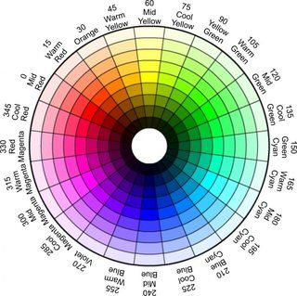

**Figure 3.5** **HSV Color Wheel**

1. Histogram of H-plane

Here, as a first step of flower recognition process, we have to identify the color of the input flower. The H-plane in HSV color model represents color information. So color can be identified by finding histogram of H-plane. The Hue value at the maxima in histogram represents the color of the input flower as the background is assumed to be white. Hue is an angle from 0 degrees to 360 degrees as shown in figure 1.1 but in openCV, the range is 0 to 180. OpenCv function used:

* calcHist();

1. Find Dominant color and create HashMap DB1

Once the histogram of H-plane is calculated, the hue value at maxima is compared with the hue ranges for different color. The color corresponding to the range in which the maxima falls is the dominant color of the input flower. Pick the flowers of that color from main database and create a HashMap DB1.

**3.4.2 COMPARISION ON BASIS OF SHAPE FEATURE**

1. Color image segmentation

Color image segmentation means segmenting a portion of particular color from image. Once the color of flower is found, we can segment out the flower from background. OpenCV function used:

* inRange();

1. Find contours and discard noise

While doing color image segmentation, we may find some unwanted noise or some non-connected parts of flower as noise. Area of the segments is the criteria to discard all these and select the flower only. For that, connected components (contours) are found first and then their areas are compared. The largest contour is picked. OpenCV functions used:

* findContours();
* contourArea();

1. Compare shapes

Hu-moments are used to match the shape of input flower with that of flowers in DB1. Hu-moments are selected as a shape comparison method because they are proved to be invariants to the image scale and rotation. So, shapes can be compared irrespective of flower size and rotation. OpenCV function used:

* matchShapes();

1. create HashMap DB2

The method for comparing shapes will return a value (here matching Factor) representing that how much match is there. The lower the value, higher is the match. DB2 is created by picking up the lowest three values of matchFactor provided that the value is less than particular threshold (here MATCH_FACTOR_TH) to ensure that only relevant shapes are picked.

**3.4.3 COMPARISION ON BASIS OF PISTIL/STAMEN.**

1. Locate the pistil/stamen

To locate the pistil/stamen of input flower, the flower itself has to be located in the whole image. To achieve that, a rectangle enclosing the flower(bounding box) is found first. Predefined region(here, start from 34% of height and 34% of width and take 1/3rd of height and 1/3rd of width) of that rectangle is selected to find the pistil/stamen. OpenCV function used:

* boundingRect();

1. Find area of pistil/stamen

While taking predefined region of the flower as pistil/stamen, some extra part (petal) of the flower may also come in that region. To discriminate better between pistil/stamen and petal, contrast stretching is applied. Same as section 3.4.1, histogram of H-plane is calculated and two maximas (lowerMaxPos and upperMaxPos) are found as pistil/stamen and petals are assumed to have different colors. After that, relative areas(with respect to the area of whole flower) for both the colors(pistil/stamen and petal) are found using the same concept of color image segmentation. OpenCV functions used:

* normalize();
* calcHist();
* inRange();

1. Compare relative pistil/stamen area and show the output

The pistil/stamen areas found by the above mentioned method are compared with those of the flowers in DB2 with some relaxation (here REL_AREA_TH). So, ultimately the flower/flowers which passes through all the three levels of filtering (color, shape and pistil/stamen) are displayed as output with available data related to that flower(here name of the flower).

If even after comparing stamen/ pistil area single output is not achieved then an interactive interface is introduced were the user can select the right output hence identifying the flower themselves by double clicking on the flower most similar to the flower image they have uploaded.

**CHAPTER 4**

**RESULT AND DISCUSSIONS**

There are millions of named species of flowering plants in the world. Everyday, many blooming flowers are seen in parks, gardens, at road sides, etc. Identifying plants is a crucial and unsure task. Experienced expert mostly do this identification of plants according to their flowers. Whereas someone non experts cannot do so without proper protocol by just looking at the flower as they know nothing about these flowers not even their common name. Hence, they have to take help either from guide books or web pages. There are several books imbibed with information on flowers but it becomes quite difficult for a human brain to remember all those details. It is quite difficult to search for a scientific name when backend information is not available. The search on Internet is restricted to keywords. Therefore the Internet approach is also not practical and fees-able in every situation. The proposed software here is developed to provide a solution to this problem in an effective and efficient way.

The window forms are designed using user friendly interfaces for smooth communication of user with software. These window forms are shown below with their description.

1. Splash screen: It is the first screen of the proposed software system. It appears while the programs are loaded. It can also be called the introduction page as flash screen includes brief introduction to the system and contains information about the people involved in its development. Below figure shows the flash screen of the application.



**Figure 4.1** **Splash Screen Of The Software**

1. Login screen: this is the login page for the user. Here users can be either professor, students or other experts of floriculture and landscaping department. If user does not have any account then he can login by clicking signup. The user can fill the user name and password in text box if they have an account and if the details are correct the user logs in.

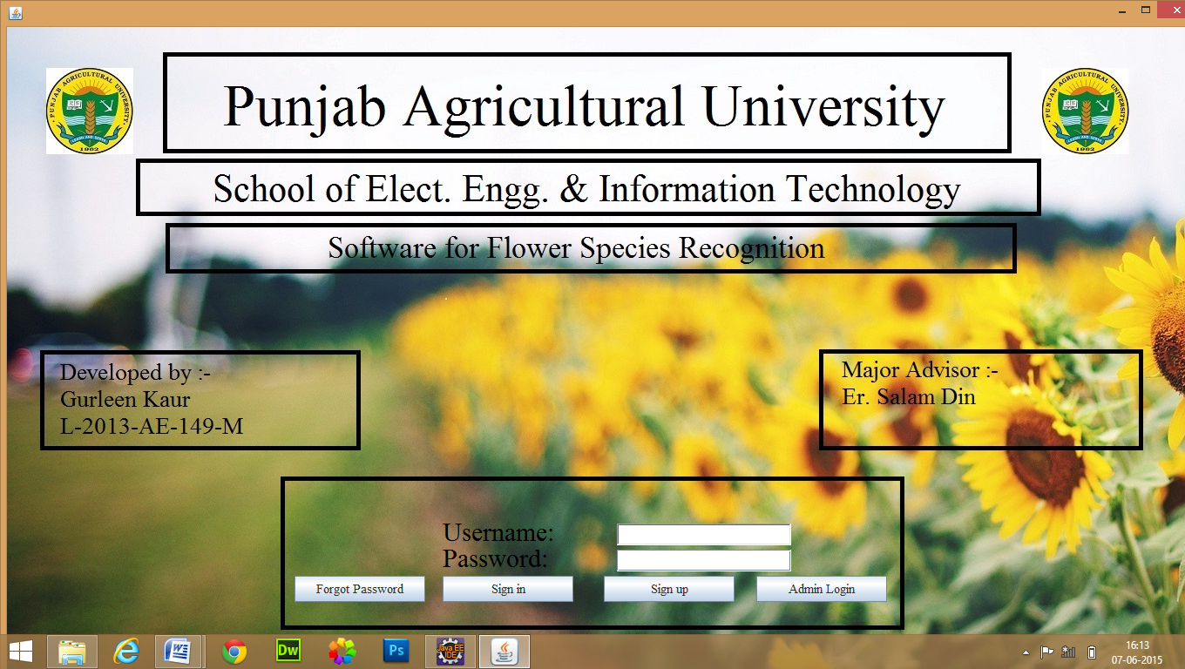

**Figure 4.2** **Login Screen Of The Software**

1. Registration page: A new user has to first register to access the system. The below given screen gives all the essential details which the user has to fill. After filling all the information successfully click on submit button and the user gets registered.

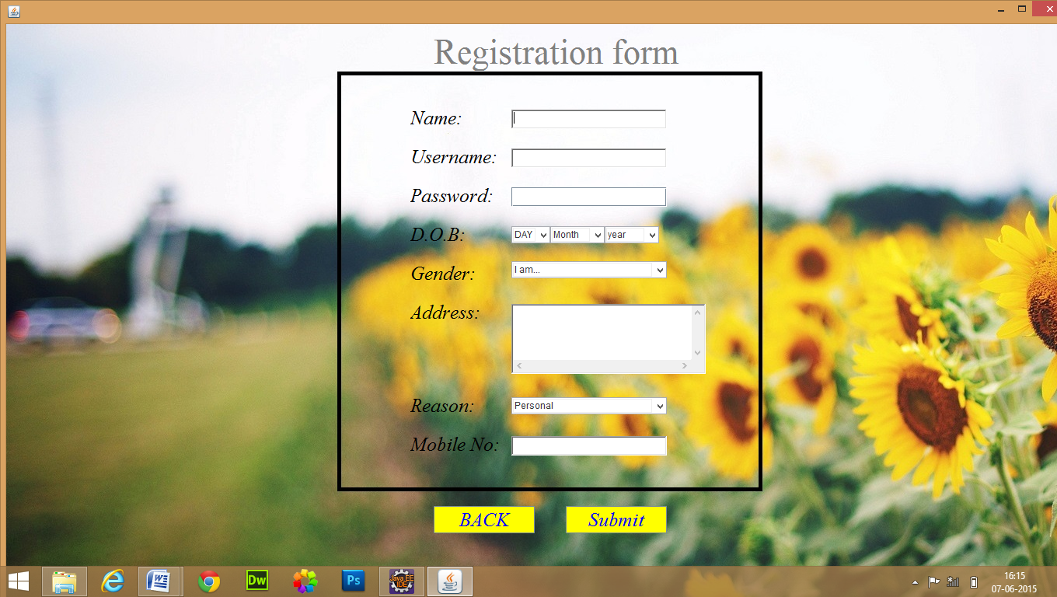

**Figure 4.3** **Registration Screen Of The Software**

1. Welcome page/ main form: Using this form user can perform various functions. User can either logout his/ her account, update their profile information, delete there profile hence logging out and test the software to identify the flower.



**Figure 4.4** **Welcome Page For The User**

1. Edit profile: The user can reset his profile information except his username through this form.



**Figure 4.5** **Edit Profile Screen Of The Software**

1. Uploading the image: user can click on the upload button and browse through whole computer to select the flower he/ she wants to identify. After that preview of image is given and if user clicks on proceed button processing of that image starts.

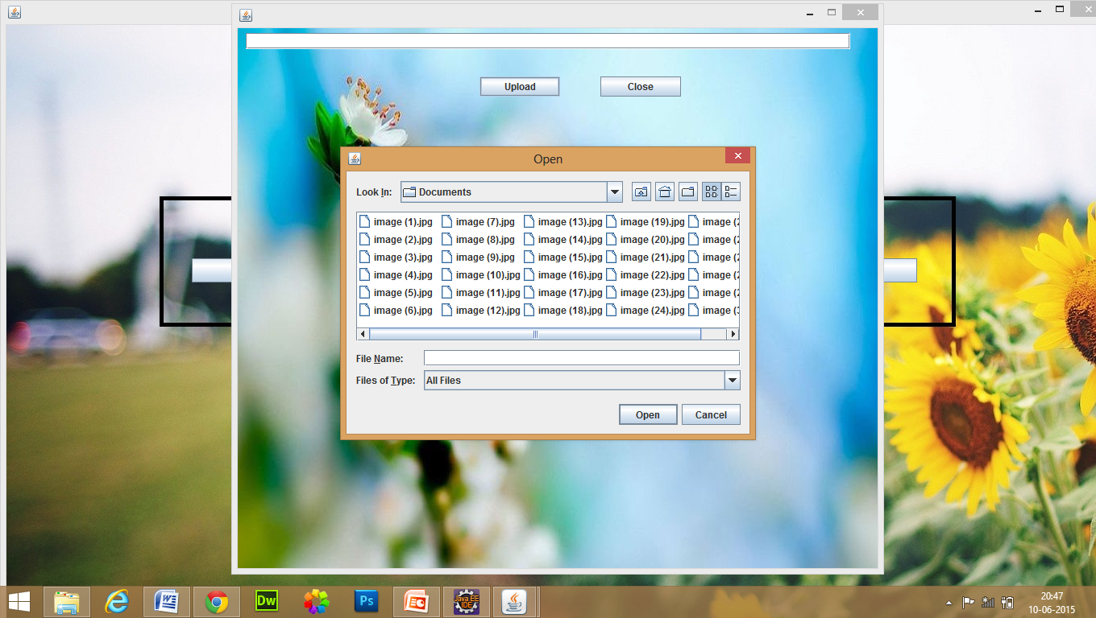

**Figure 4.6** **Upload Image Screen Of The Software**

1. Admin approval screen: In this screen admin has to fill their user name and password as an approval to the user so that user can begin the processing on the input image. This page also displays the image of the flower uploaded by the user from which admin can check if the correct image is uploaded or not.

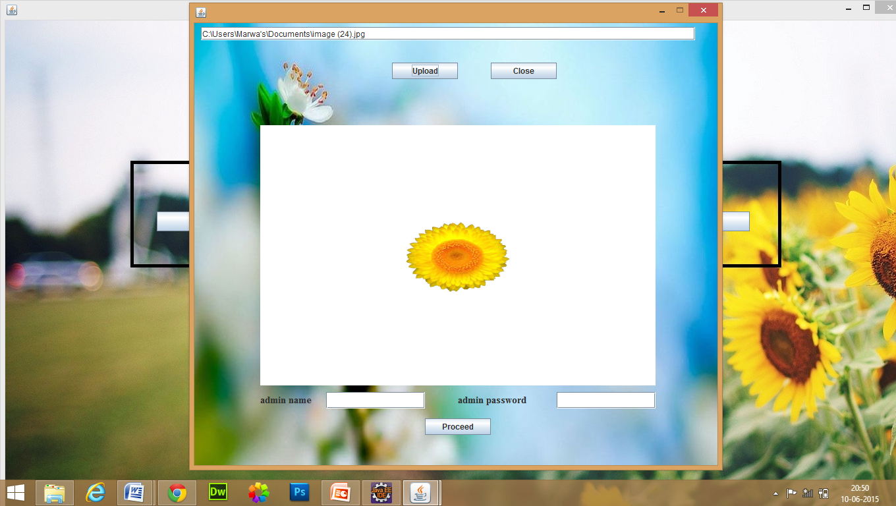

**Figure 4.7** **Admin Approval Screen**

1. Outputs: After image processing is performed on the input image accordingly output is generated. If more than one output is generated the user can double click on the correct output hence user identifies the flower through interactive interface of this software.



**Figure 4.8** **Output Screen Of The Software**

1. Main frame of admin: This screen appears once admin logs into the software. Using this screen admin can perform various functions such as add new flowers to the software for comparison, edit any user profile or delete any user profile by giving there username.

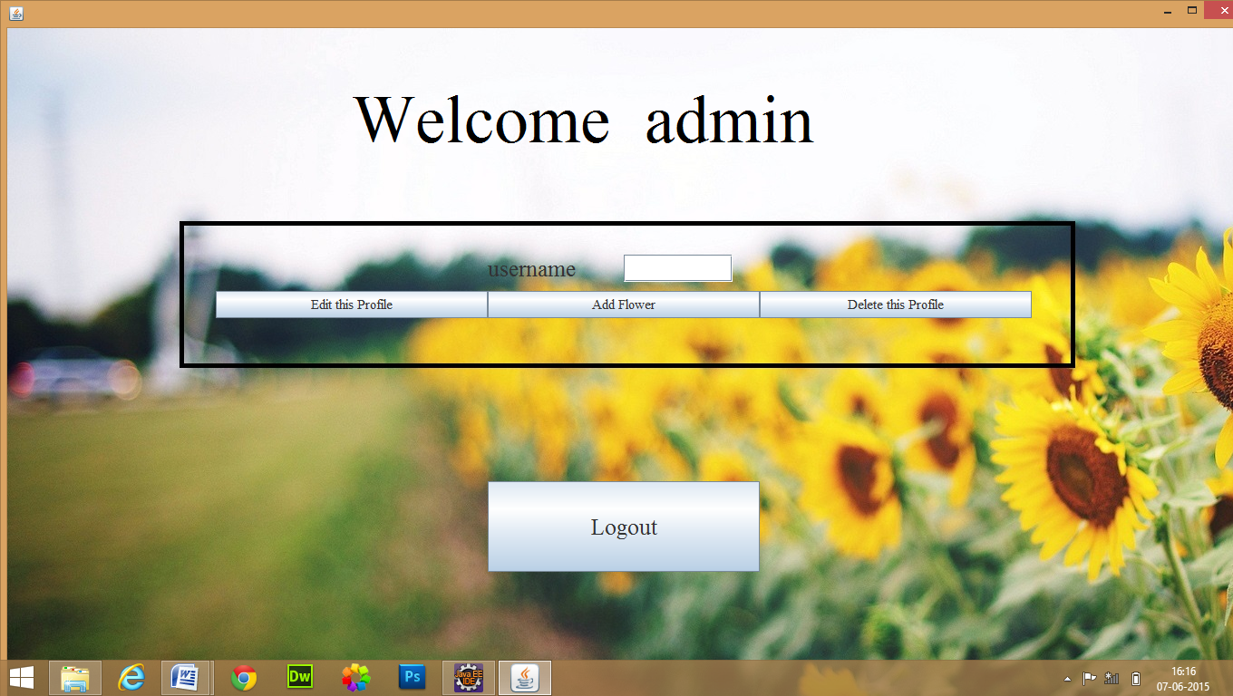

**Figure 4.9** **Main Screen Of Admin**

1. Forget password: This is the forget password screen for the software. Whenever user forgets their password they can click on the forget password button after submitting their username. This will enable them to login using their phone number as password.

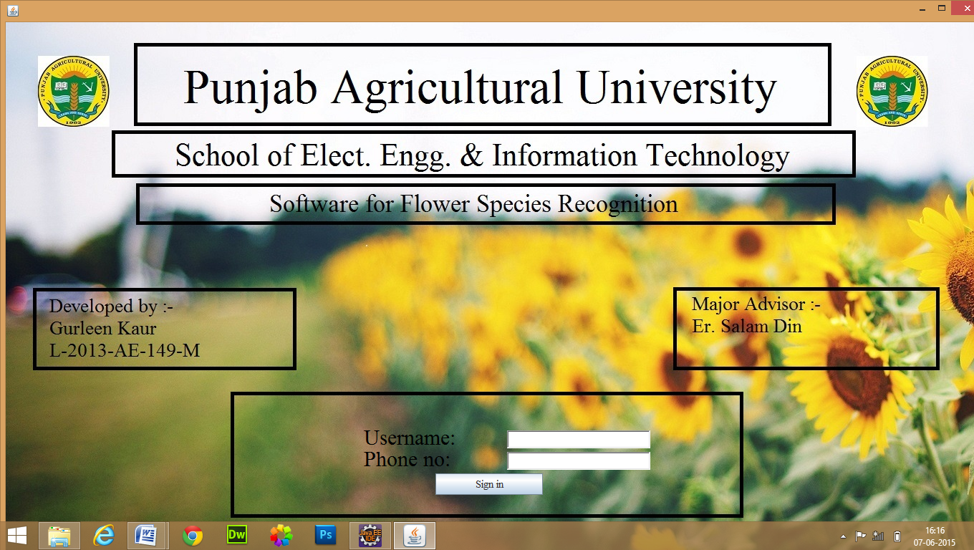

**Figure 4.10** **Forget Password Screen**

This software will helps researchers and students for identification of flowers for their research work. Through this software we apply image processing techniques on the flower image to gain information regarding color, shape and stamen/pistil area of the flower. Firstly we do the RGB (Red Green Blue) to HSV (Hue Saturation Value) conversion of the image. Then, after fixing the values of Saturation and brightness, a histogram is calculated for H values of image from which dominant color of flower is calculated. After that color image segmentation of image is done and HU-moments are selected for shape comparison of flowers. Stamen/pistil area of flowers is achieved by creating a bounding box around flower region and creating a bounding box of 34%of previous width and 1/3rd of previous height from which comparison is done. In this research work a flower image database is used to evaluate the performance of proposed method. This database consists of 24 species of flower. These flower images are taken by scanning 24 winter annual flowers with white background. To ensure the robustness of proposed software a number of different scanners are used. Before recognition all flower images are rescaled to be the same size. To show the effectiveness of the proposed approach comparison of the recognition results of proposed approach with various feature sets is done.

**Table 1 Comparison Of Recognition Rate**

|  |  |
| --- | --- |
| Method | Recognition rate% |
| Proposed approach 1 (using only color feature) | 12.3 |
| Proposed approach 2 (using color and shape feature) | 75.3 |
| Proposed approach 3 (using color, shape and pistil/ stamen feature) | 83.0 |

It is seen that the shape and color feature gives more discriminating ability than the color feature alone. The approach using shape and color feature of flower region can achieve a very high recognition rate. Furthermore, the best performances obtained by combining the shape, color and the pistil/ stamen feature of the flower region. It is clear that the proposed approach reaches the best recognition rate.

**Figure 4.11 Comparison of proposed approaches on basis of recognition rates**

The administrator has the complete control of the services of the system. The administrator can be Head of department, Professors or any other experts. The administrator will have the authority to edit or delete any user’s information. Admin can also add new flowers in the database. The users are authorized to view the flower along with their scientific name only if they upload a digital image of the flower. The user uploaded image is compared with the images in the database through image processing techniques. If the user forgets their password, they have got a facility to login using the security question added at the time of creating account.

The prototype system is complete in itself and ready to be implemented but every software project has to undergo changes as per the requirements of future time. The same is true for this system. Nowadays the computer technologies are used all over the world in every part of the country but many humans are unable to use them because of illiteracy. This software could be made more easy to use and user friendly by giving the facility of language conversion. We can also improvise the software by adding new images of flowers to the software’s database.

**CHAPTER 5**

**SUMMARY**

The goal of this research was to develop a software application which could recognize a flower from its scanned image. The traditional approach for recognition of flowers is not easy for flowers that are not part of our day to day life. So in this research work we present freeware software for recognizing flower. The objective of the study is (i)To develop software for flower recognition using image processing techniques. (ii)Prototype implementation and testing of proposed software. The summary of the research work is given below.

In chapter one it is discussed that flower identification is an important aspect for many physiological studies. It will help natural resource managers in identification of similar plants where flowers are their differentiating factor. There are many plants which have same physical attributes such as same plant type same shape of leaves, etc. in such cases the various factors of flowers of those plants help a taxonomist in identifying the plant. In this chapter the traditional approach and proposed approach for flower identification is also discussed and need for the proposed approach is justified. The various technologies used in developing the software are explained briefly. Also, objectives of the research paper are also mentioned.

In chapter two various research works are discussed in brief detail which were reviewed while developing the synopsis of the research work. It also include the research works of relevant information sources which helps determine what is already known about the topic and how extensively the topic has already been researched. Identification of key questions about the topic that needed further research were also discovered through this chapter. It also gave means of determining what approaches might be of most benefit in further developing the software.

Chapter three has the details of the stages of life cycle of the software. It has the information about detailed phases by following which the software was developed. Firstly the currently working system is analyzed and an approach is given to improve the same. It is checked if the proposed approach is feasible or not. Then a document is prepared which contains all the requirement specification of the software following which a prototype design is developed for user to check if their requirement specifications are met. If user is satisfied with the design and no changes are suggested by them then this design is converted into the system using various technologies. Details of all such technologies along with details of all the image processing techniques used for the development of the system are also given in this chapter. This developed software id then deployed so that it could be run on any system with JVM installed on it. After the deployment this software is installed on system.

In chapter four deals with the result and discussions of the research work. The effectiveness of the proposed approach is justified in this chapter. Details about what the software can do and what the services are provided by the software to the user by administrator are given in this software. Details regarding future scope to improvise this software and suggestions for future research are also given.

The main purpose of this research work was to develop a software which could recognize a flower from its scanned image which is fulfilled. A new software is developed which can be considered inexpensive, more accurate, scanner independent and suitable for a non-expert methodology for recognition of flowers.

**REFERENCES**

Aleya K F and Samanta D (2013) Automated Damaged Flower Detection Using Image Processing. *Journal of Global Research in Computer Science* 3:297-301

Apriyanti D H , Arymurthy A M and Handoko L T(2013) Identification of Orchid Species Using Content-Based Flower Image Retrieval. *2013 International Conference on Computer, Control, Informatics and Its Applications Jakarta, Indonesia* :53-59

Dash T and Nayak T (2012),A java based tool for basic image processing and edge detection. *Journal of Global Research in Computer Science* 3:57-60

Fukuda K, Takiguchi T and Ariki Y (2008) Multiple classifier based on fuzzy c-means for a flower image retrieval. *In: Proc. Int. Workshop on Nonlinear Circuits and Signal Processing* *(NCSP’2008):* 76–79

Guru D S, Sharath Y H and Manjunath S (2010) Texture Features and KNN in Classification of Flower Images. *IJCA Special Issue on RTIPPR : 21-29*

Holmes S, Kapelner A and Lee P P (2009) An Interactive Java Statistical Image Segmentation System: GemIdent. *Journal of Statistical Software* 30:1-20

Hong A, Chen G, Li J, Chi Z and Zhang D (2004) A flower image retrieval method based on ROI feature. *Journal of Zhejiang University (Science)* 5:764–772

Kim J H, Huang R G, Jin S H and Hong K S (2009) Mobile-based flower recognition system. *IITA'09 Proceedings of the 3rd international conference on Intelligent information technology application* : 580-583

Lee K B and Hong K S (2013) An implementation of leaf recognition system. *International journal of bio-science and bio-technology* 5: 57-66

Nilsback M E and Zisserman A (2006) A Visual Vocabulary for Flower Classification. *Computer Vision and Pattern Recognition,* 2006 *IEEE Computer Society Conference* 2:1447 - 1454

Pornpanomchai C, Kuakiatngam C, Supapattranon P and Siriwisesokul N (2011) Leaf and flower recognition system (e-Botanist). *International Journal of Engineering and Technology* 3: 347-351

Priya K L and Durairaj D C, (2013) Pest Control in Agricultural Plantations Using Image Processing. *IOSR Journal of Electronics and Communication Engineering* 6: 68-74

Singh H and Kaur T (2013) Empirical Study of Various Edge Detection Techniques for Gray Scale Images. *International Journal of Advanced Research in Computer Science and Software Engineering* 3:76–80

Singh Y and Vij K (2012) Enhancement of Images Using Histogram Processing Techniques. *Int J Comp Tech Appl* 2: 309-313

Tiay T , Benyaphaichit P, and Riyamongkol P(2014) Flower Recognition System Based on Image Processing. *The 2014 Third ICT International Student Project Conference (ICT-ISPC2014)*:99-102

Vibhute A and Bodhe S (2012) Applications of Image Processing in Agriculture: A Survey. *Int. Journal of Computer Applications* 52:34-40

Yetirajam M and Nayak M R (2012),A Java Applet Based Tool for Histogram Equalization and Edge Detection. *International Journal of Advanced Research in Computer Engineering & Technology* 1:90-94

Zou J and Nagy G (2004) Evaluation of model-based interactive flower recognition. *Proc Int Conf Pattern Recogn* 2:311–314